ELEG 312 - Example Problems Chapter 10-3

**Example 10.9**

Consider a common-gate amplifier with *gm* = 1.25 mA/V, *ro* = 20 k, *Cgs* = 20 fF, *Cgd* = 5 fF, *CL* = 25 fF, *Rsig* = 10 k, and *RL* = 20 k. Assume that *CL* includes *Cdb*. Determine the input resistance, the midband gain, and the upper 3-dB frequency *fH*.

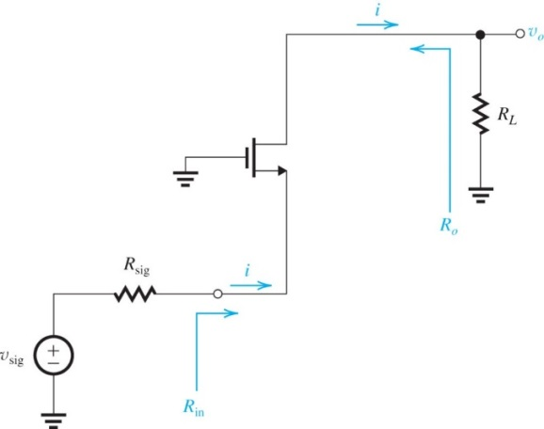

**Example 10.10**

This example illustrates the advantages of cascoding by comparing the performance of a cascode amplifier with that of a common-source amplifier in two cases:

(a) The resistance of the signal source is significant, *Rsig* = 10 k.

(b) *Rsig* is negligibly small.

Assume all MOSFETs have *gm* = 1.25 mA/V, *ro* = 20 k, *Cgs* = 20 fF, *Cgd* = 5 fF, *Cdb* = 5 fF, and *CL* (excluding *Cdb*) = 10 fF. For case (a), let *RL* = *ro* = 20 k for both amplifiers. For case (b), let *RL* = *ro* = 20 k for the CS amplifier and *RL* = *Ro* for the cascode amplifier. For all cases, determine *Av*, *fH*, and *ft*.

(a) The resistance of the signal source is significant, *Rsig* = 10 k. For case (a), let *RL* = *ro* = 20 k for both amplifiers.

(b) *Rsig* is negligibly small. For case (b), let *RL* = *ro* = 20 k for the CS amplifier and *RL* = *Ro* for the cascode amplifier.

**Example 10.11**

A source follower operated at *gm* = 2 mA/V and *ro* = 20 k is fed with a signal source for which *R*sig = 10 k and is loaded in a resistance *RL* = 20 k. The MOSFET has *Cgs* = 20 fF, *Cgd* = 5 fF, and *gmb* = *χgm* where *χ* = 0.2, and the total capacitance at the output *CL* = 15 fF. Determine *AM*, *fT*, *fZ*, *Q*, *fP*1, *fP*2, and *f*3dB.